Experiment-14

Aim
To perform perspective transformation on an image using Python and OpenCV.

Procedure
- Import the OpenCV and NumPy libraries.
- Read the input image using cv2.imread().
- Select four points from the original image.
- Define four corresponding destination points.
- Calculate the perspective transformation matrix using cv2.getPerspectiveTransform().
- Apply the transformation using cv2.warpPerspective().
- Display the original and transformed images.

Code
import cv2import numpy as np
img = cv2.imread("image.jpg")
pts1 = np.float32([[50, 50], [300, 50],
[50, 300], [300, 300]])
pts2 = np.float32([[0, 0], [300, 0],
[0, 300], [300, 300]])
matrix = cv2.getPerspectiveTransform(pts1, pts2)
result = cv2.warpPerspective(img, matrix, (300, 300))
cv2.imshow("Original Image", img)cv2.imshow("Perspective Transformation", result)
cv2.waitKey(0)cv2.destroyAllWindows()

Sample Input
An image named image.jpg.

Sample Output
- Original image displayed in the first window.
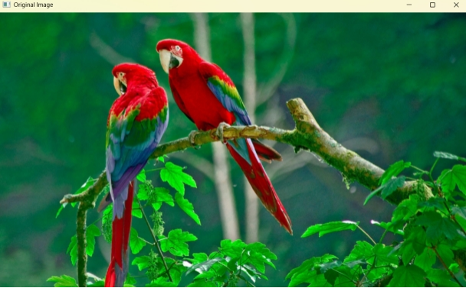
- Perspective-transformed image displayed in the second window.
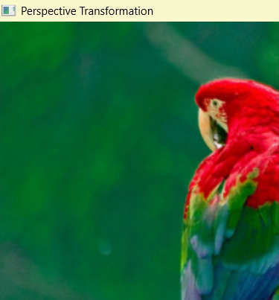

Result
Thus, perspective transformation was successfully performed on the input image using Python and OpenCV.

